
Specification & Technical Guide
E3MINI Single-Phase Inverters

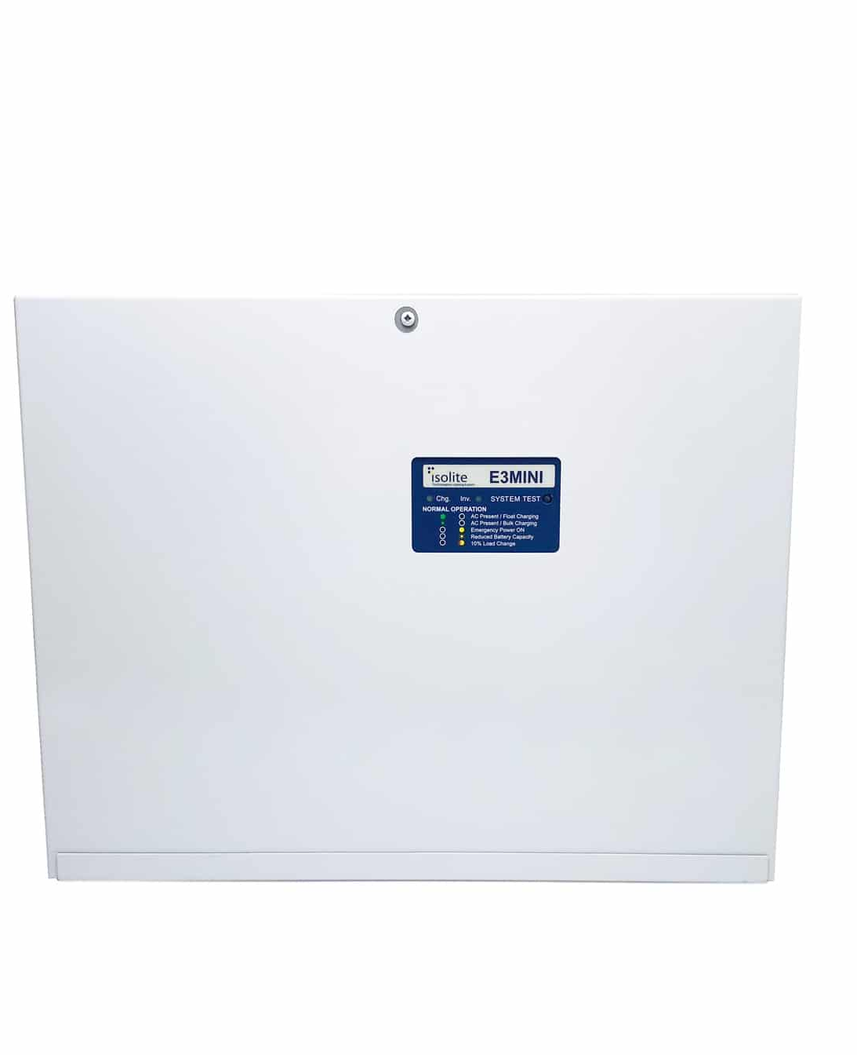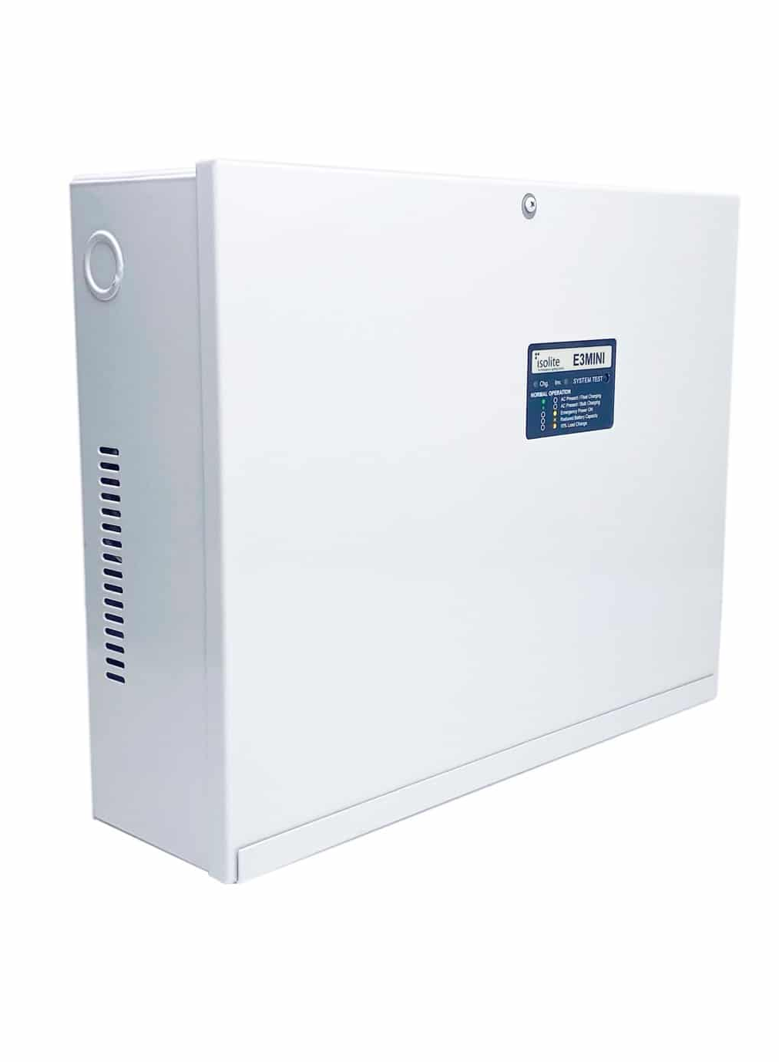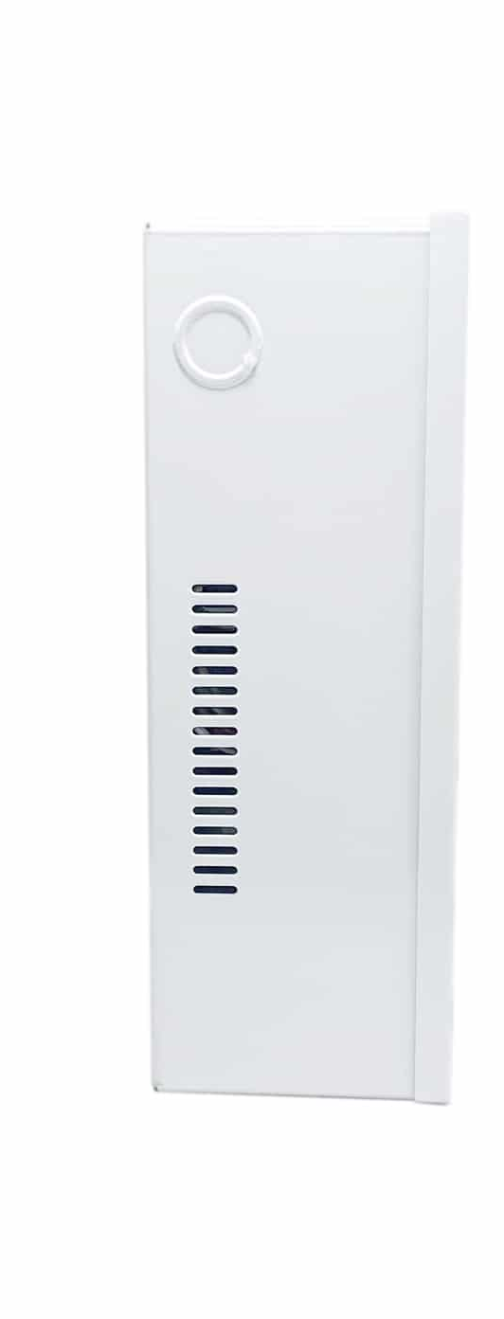

E3MINI INVERTER SERIES
Mini Inverter for Emergency Lighting

Document Overview
This specification document will provide all technical data and/or specifications required to properly specify/quote the E3MINI Modular Emergency Lighting Central Inverter series. All phases of operation of this product will be detailed in this document. If additional technical information is required beyond this document, please contact Isolite directly.

Disclaimer
Isolite Corporation reserves the right to modify, delete, or add any information in this document without notice.

Point(s) of Contact
Isolite Technical Support 1-800-967-5573 quotes@Isolite.com

1.0 General Information

1.1 Specification
This specification shall provide all electrical, technical and mechanical data relevant to the E3MINI Inverter system. The inverter shall supply Pure Sine Wave emergency power equivalent in quality to utility grade power. A high crest factor with substantial overload protection allows this inverter to drive difficult loads reliably. LED indicators, Self-Diagnostics, and One-Button Push System Tests ensure industry-leading reliability.

1.2 Standards
UL 924
NFPA 101 Life Safety Code
NFPA 70 National Electrical Code
OSHA
OSHPD Preapproval of Manufacturer’s Certification (OPM)

2.0 Product

2.1 Manufacturer
The Inverter referenced within this specification document shall be the E3MINI Inverter manufactured by Isolite Corporation in Trevose, PA.

2.1.1 Manufacturer Quality Assurance
Manufacturer shall be registered to the ISO 9001:2015 quality standards.

2.2 Requirements
Furnish and install an Isolite E3MINI Modular Single-Phase Inverter that meets the following requirements for a minimum time period of 90 minutes:

Input Voltage 120/277 VAC Output Voltage 120/277 VAC Rating 125-550 W/VA

2.3 Input Specifications

Phase Configuration | Single Phase (2-wire plus ground)
Input Voltage | 120 or 277 VAC — user selectable
Operating Range | ± 10% Nominal Utility Voltage
Frequency Range | 60 Hz ± 2 Hz
Power Factor | 0.5 Lag/0.5 Lead ¹
Current Limit | 125%
Surge Protection | Compliant and tested per UL 924
Brown-Out Protection | 87.5% of Nominal Utility Voltage
Short Circuit Withstand | N/A

2.4 Output Specifications

Output Voltage | 120 or 277 VAC — user selectable
Crest Factor | 10× (125VA, 375VA); 5× (250VA, 550VA)
Overload Capability | 110% generates overload fault
Load Power Factor | 0.5 lead to 0.5 lag
Power Factor Rating | KW = KVA ²
Harmonic Distortion | < 3%
Frequency Range | 60Hz +/- 0.02 Hz crystal controlled during emergency mode
Transfer Time | 50 ms standard; programmable 1 s
Output Configuration | 1 normally-on and 3 configurable normally-off/switched outputs for the 125VA and 250VA models. 1 normally-on and 4 configurable normally-off/switched output types for the 375VA and 550VA models.  FD option allows 0-10V dimming

2.5 Battery

Run Time | 90 Minutes (longer with load less than rating)(120min with option EB)
Type | Premium long‑life VRLA (sealed lead calcium)
Charging | Three Rate Charger circuit fully temperature compensated
Recharge Time | ≤ 24 hours
Buss Voltage | 24 VDC nominal; 2.26–2.27 V/cell float (temp‑comp); 1.67 V/cell LVD
Battery Warranty | 1 year full, 9 years pro-rata
Fire Safety | Flame Retardant UL 94V-0
Design | Front Terminal (ease of access)
Battery Approval | IEC 60896-21 and 60896-22 Certified  UL Certified

- Input Power factor is heavily influenced from pass-through of connected load
- The inverter can support wide power factor variations (0.5 Lag/0.5 Lead); however, the unity Power Factor Rating (KW=KVA) specifies the maximum output limits that cannot be exceeded

2.6 Design

2.6.1 Enclosure
The E3MINI uses a compact, single‑cabinet architecture for wall‑mount installation.

2.6.2 Convection Cooling
Thermal design performance shall achieve 100% reliance on natural convection during the standby or “Normal Operation” mode (99.9% of product life). Fans shall only be operational during “Emergency Operation” mode and bulk re-charging of the batteries. This increases efficiency, improves reliability, and eliminates the need for air filters and routine dust-removal maintenance commonly found with units employing continuous operation fans.

2.6.3 Front Access
All inverters shall utilize a front-facing access door.

2.6.4 DC Isolation from AC
Batteries shall have isolation from the incoming or outgoing AC line voltage and Earth Ground. This feature allows a direct short between any battery-to-chassis ground without damage.

2.6.5 Inverter Compliance
The inverter shall be tested and listed by Underwriters Laboratory to the UL 924 standard which also includes the Self-testing and Self-Diagnostic portion of the standard. Self-Testing shall be performed monthly for a minimum of 30 seconds and annually for a minimum of 90 minutes to comply and also contain fully programmable, password protected Load-Reduction fault programming capabilities.

2.7 Alarms and Indicators
2.7.1 Indicators
The inverter provides two bi-color LED indicators on the front panel.
LED1 (Charger / Line Status): Green = AC present/charging; blinking green = high‑rate charge; red = charger/start‑up fault.
LED2 (Inverter / Battery Status): Yellow = inverter mode; blinking yellow = low battery; red = inverter fault.

2.7.2 Minor Alarm
A Minor Alarm occurs if the connected load changes by more than 10% after transfer to inverter mode. LED2 alternates Yellow/Red. Output remains energized.
2.7.3 Major Alarms
A Major Alarm forces output to cease. The condition must be corrected and the system reset via the Test button or by cycling the System ON/OFF switch.

2.7.4 Start-Up Faults (LED1 + LED2 Red)
1 Blink – Incorrect AC input (does not match voltage-select jumper)
2 Blinks – Voltage-select jumper missing
3 Blinks – Transformer wiring reversed
4 Blinks – Low battery voltage / wiring issue
5 Blinks – Output overload or short circuit
6 Blinks – Inverter module fault
7 Blinks – AC backfeed detected at output

2.7.5 Charger Faults (LED1 Red)
1 Blink – Over-temperature (heatsink); self-clearing
2 Blinks – Voltage-select jumper missing
3 Blinks – AC fuse blown
4 Blinks – Charger/Inverter module fault

2.7.6 Inverter Faults (LED2 Red)
1 Blink – Over-temperature (heatsink); self-clearing
2 Blinks – Voltage-select jumper missing
3 Blinks – AC backfeed detected
4 Blinks – Output overload or short circuit
5 Blinks – Inverter module fault
6 Blinks – LVD (battery below threshold); shuts down after 1 minute

2.7.7 Reset Procedure
Press the Test button or cycle the System ON/OFF switch to clear Major Alarms.

2.7.8 Self-Clearing Conditions
Over-temperature conditions clear automatically once cooled.

2.8 Quality Assurance

2.8.1 Manufacturer Testing
All inverters shall be manufactured in Trevose, PA. End-of-line quality tests shall be performed by the build team. Each unit produced shall be 100% load tested and run through a series of durability tests, fault tests and unit-specific option tests by the Quality Control Team. The inverter shall then be inspected a third time to ensure 100% specification compliance prior to shipping.

2.8.2 Self-Testing
Each inverter shall utilize several different methods of self-testing. On start-up, each unit shall test the following prior to entering Normal Operation Mode: Communications, Set-Up Conflict, Low Battery, Back-feed, Transfer/AC Fuse, Short/Overload, Miswire, and Incorrect AC Input. Scheduled Self-Tests can be programmed into the unit for Monthly tests and Yearly 90-minute NFPA compliance tests. In addition, each unit shall continuously test itself and notify users of issues via the Onboard Diagnostics.

Fabrication

2.9.1 Cabinet Construction
The inverter cabinets shall be made from 16 gauge cold-rolled steel. All corners and seams shall be welded and ground smooth before powder coating.
Each cabinet design shall have multiple pre-punched Electrical Knock Outs (EKO) on the top and sides for quick and clean conduit installation by a qualified electrician. Seismic Certified Brackets shall be available as an option (see Section 7.0 “Options”). All Cabinets are designed for NEMA Type-1 compliance.

2.9.2 Cabinet Finish
Each inverter cabinet is powder coated

2.9.3 Manufacturing Method/Location
Each inverter shall be designed, developed, and manufactured in Trevose, PA. Each unit shall be built to order and therefore fully custom. Each unit shall be 100% tested for an extended period of time before being released to be shipped.

3.0 Functionality

3.1 Normal Operation (Pass-Through Mode)
When normal utility power is present, the inverter shall run in Pass-Through Mode. Utility Power will be the source of power for all circuits, simply passing through the inverter unit to supply those circuits. The inverter unit will consume a small amount of power to run internal monitoring circuits and provide float charging to the battery circuit.

3.2 Emergency Operation (Discharging Mode)
When a loss of utility power occurs on any phase, the inverter shall detect this and switch to Discharging Mode. The inverter shall transfer to supplying AC to the connected circuits in less than 50 mS. Once utility power is restored, the inverter shall switch back to using utility power to supply the connected circuits.

3.3 Recharge Operation (Charging Mode)
The inverter shall revert to Charging Mode when utility power is returned to the unit. If batteries are fully depleted, they shall be fully recharged within 24 hours. The Three Rate Charger circuit is fully temperature-compensated for added reliability.

4.0 Environment

4.1 Recommended Location:
The manufacturer recommends that all Inverter Cabinets reside in a dry, conditioned space with normal ventilation. Relative Humidity shall be <95% non-condensing. All Cabinets are designed for NEMA Type-1 compliance.

4.2 Operating Temperature:
Inverter Operating Temperature 68°F to 86°F (20°C to 30°C). Average temperatures above 77°F (25°C) will reduce the service life of the batteries.

4.3 Storage Temperature:
Storage before installation is critical for battery life expectancy and warranty. Batteries should be stored indoors in a clean, dry, and cool location. Storage at higher temperatures will result in accelerated rates of self-discharge and possible deterioration of battery performance and life. The recommended storage schedule based on temperature is as follows:

51°F (11°C) to 77°F (25°C) 6 Months
78°F (26°C) to 92°F (33°C) 3 Months

4.4 Elevation:
No derating required up to 1,600 Meters (5,280 ft.)
Apply derating of 2% per 125M up to maximum of 2,500 Meters (8,250 ft.) Consult factory for elevations greater than 2,500 Meters (8,250ft)

5.0 Installation

5.1 Site Requirements
The following Site Requirements are imperative to proper system installation.

5.1.1 Battery Chemistry
The inverter shall be supplied with Lead Acid batteries standard. These Batteries shall use Absorbent Glass Material (AGM). The electrolyte used in the batteries shall not exceed 50 gallons in total, which is compliant with current IFC/UFC codes.

5.1.2 Ventilation
As previously stated in section “2.6.2 Convection Cooling”, each inverter shall be cooled by natural convection. For LA battery systems, the ventilation requirements for human occupancy and electronic equipment will meet or exceed the requirements for the batteries. No additional HVAC engineering shall be necessary for LA battery ventilation. The choice of mounting location should

made based upon the location being clean and dust free. Do not choose a location where particulate matter is present from industrial processes or manufacturing.

5.1.3 Clearance
Clearance requirements follow compliance to NEC Section 110-26 requirements of 3 feet of open space in front of the inverter.

5.2 Best Practices
The following suggestions are recommended by the manufacturer based upon the substantial base of installed products throughout the world.

5.2.1 Inspection
Upon receipt of the inverter from the freight shipping company, inspect all cabinets and/or boxes for damage or potential impact. Should any damage be present, take pictures and fully document the occurrence. Any damage should be notated on the shipping carrier’s Bill of Lading. This information should then be communicated to your local inverter representative.

5.2.2 Cabinet Modification
At no time, should any inverter cabinet be modified. This includes drilling and cutting into the cabinet. Drilling or cutting the cabinet will cause metal shavings to be present which could ultimately fall onto electrical components causing a short in the unit. If you believe modification of the cabinet is necessary, please contact Inverter Tech Support to discuss.

6.0 Options
` FD – 3‑Zone 0–10V/DALI Dimming & Fire Alarm Interface
RT – Remote Diagnostic Status Display Panel for Back Mount Inverters
AA – Audible Alarm (Buzzer)
CL – Canada Listed
EB – Extended Run Time (2h) [for 125W and 250W only; capacity reduced to 100VA and 200VA]
Z4 – Seismic Zone 4 Restraints

7.0 Dimensions/Weights
 | SIZE (W×H×D in) | WEIGHT (lb)
E3MINI-125 | 15.4×12×4.25 | 33
E3MINI-250 | 15.4×17.3×4.25 | 57
E3MINI-375 | 20×20×7.16 | 50
E3MINI-550 | 20×20×7.16 | 62

8.0 Warranty

8.1 Electronics Warranty
Refer to the standard Central Power Systems Warranty policy, which is available for download on the manufacturer’s website. All information within the Central Power Systems Warranty supersedes this document.

8.1.1 Standard Manufacturer Warranty
The standard manufacturer’s electronics warranty shall be for a period of 3 full years.

8.2 Battery Warranty
Refer to the standard Central Power Systems Warranty policy, which is available for download on the manufacturer’s website. All information within the Central Power Systems Warranty supersedes this document.

8.2.1 Batteries
The manufacturer’s warranty on batteries follows the following warranty schedule: Repair or Replacement without charge – 3 year
Pro-Rated Charge Repair or Replacement – 7 years

9.0 Support & Resources
Initial point of contact: Please contact your local inverter representative Manufacturer Support: Isolite Technical Support 1-800-526-5088
quotes@Isolite.com
https://www.Isolite.com

10.0 Ordering Logic

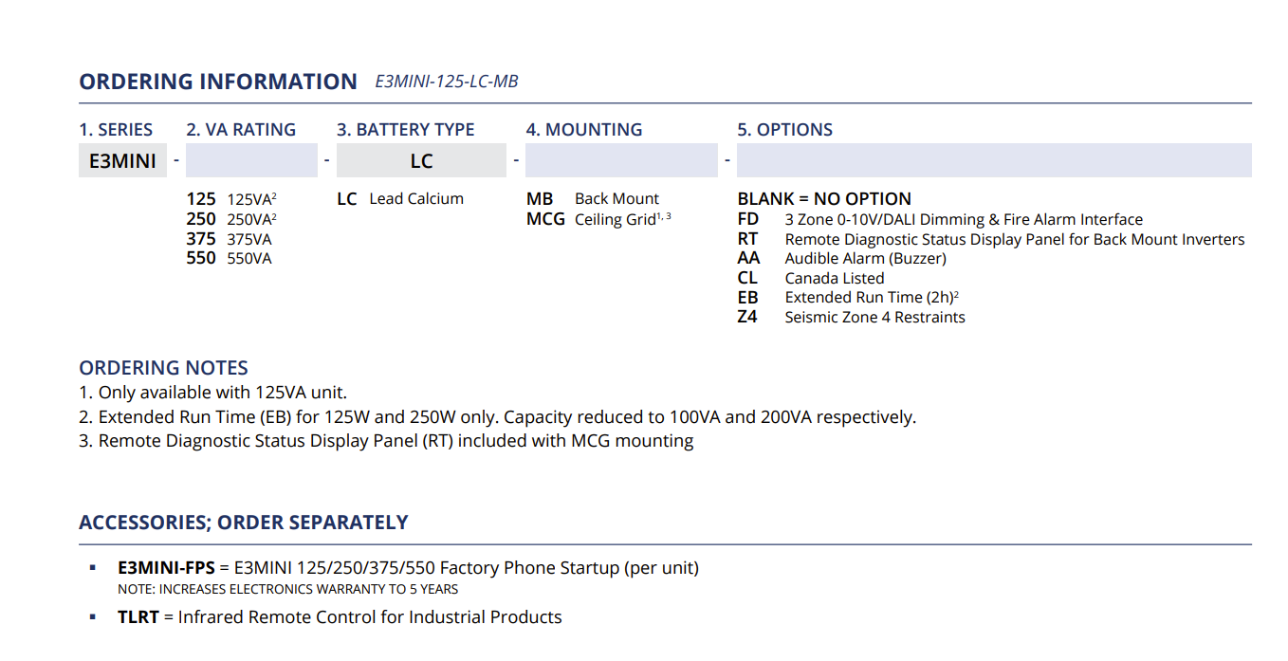

11.0 Front Panel

